 | Year 12 Methods  Term 2 Week 1 Quiz | $$\frac{}{20}$$

Name: __________________
1. | Suppose that X is the number of times a shooter hits a target in a competition. If the distribution of X is binomial, with probability of success of 0.67, calculate the probability that a shooter who takes five shots will hit the target three times.  Pr(X=3) = $\begin{matrix}5 \\ C \\ 3\end{matrix}$(0.67$)^{3}$(0.33$)^{2}$  = 0.3275 | 2
2. | A multiple choice test has 10 questions, each of whci has five possible answers. Find the probabillity that a student who guesses the answer to each question will have:  - No correct answers  $(\frac{4}{5})^{10}$ = 0.1074  - 5 or more correct answers  Classpad 0.0328  - At least 7 correct answers given that they have at least 5 correct answers.  Classpad 0.0264 P$\left(X≥7 | X≥5\right)$ | 4
3. | 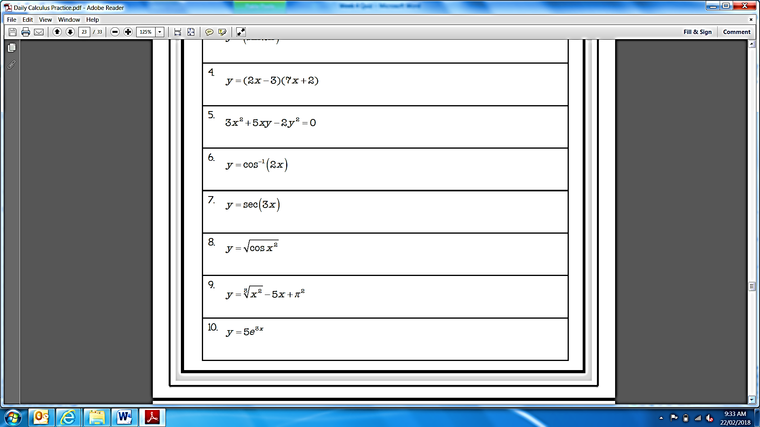  Find:  - The derivative of  $$15e^{3x}$$  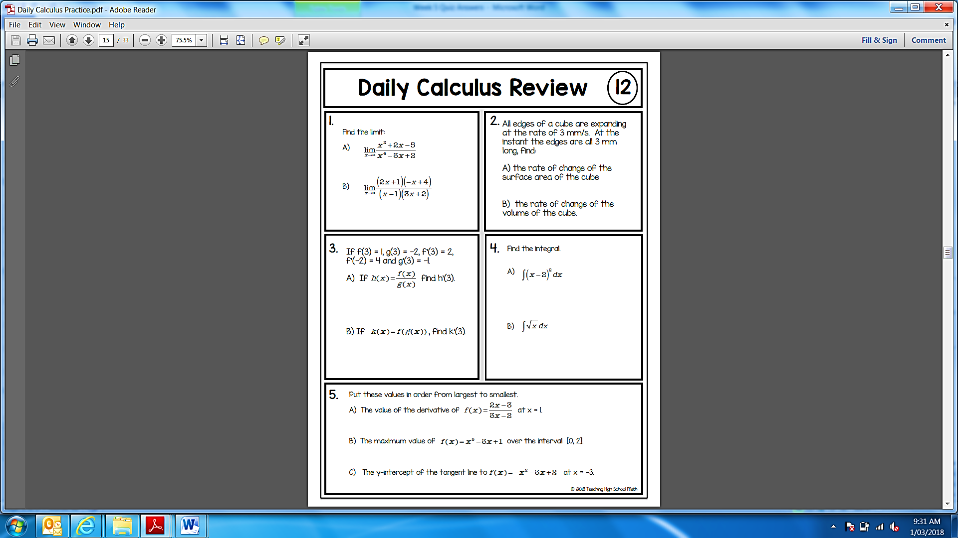  $$\int{(x-2)^{2}dx}= \frac{1}{1\left(2+1\right)}(x-2)^{2+1}= \frac{1}{3}(x-2)^{3}+c$$ | $$3$$
4. | The velocity of a body as a function of time is given as $v\left(t\right)=5e^{-2t}+4$, where t is on seconds and v is in m/s. What is the acceleration at t = 0.6? | 3
5.

